Workshop #7

Object Oriented Programming

Aitrich Technologies Pvt. Ltd.
© All rights reserved.

Introduction

This document explains the workshop module for the topic, Object oriented programming. It illustrates different unique usages for each of the object oriented concepts..

This document comes along with the workshop deliverable, JavaOOP.zip, that contains the Eclipse project for the workshop. Students may import the extracted project files into their workspace and explore the classes, closely examine the usages of each classes, and try modifications or their own programming in order to avail a hands-on experience.

Objectives

The objectives of this workshop are to allow the student to explore and try the theory he learned during the lecture, and to make him well versed in the topic, so that he can use it in the further Java Programming endeavors.

How is it organized?

Test cases are distributed into three distinct packages where each package represents the elements in object oriented concepts.

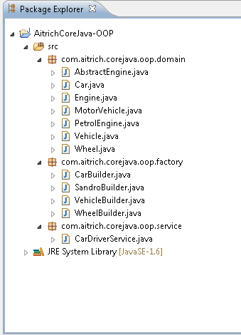

OOP concepts

Concept | Description
Class | An extended version of java.awt.Frame that adds support for the JFC/Swing component architecture
Object | JPanel is a generic lightweight container
Method | A JWindow is a container that can be displayed anywhere on the user's desktop. It does not have the title bar, window-management buttons, or other trimmings associated with a JFrame.
Message Passing | An implementation of a "push" button.
Inheritance | An implementation of a check box -- an item that can be selected or deselected, and which displays its state to the user.
Abstraction | A component that combines a button or editable field and a drop-down list. The user can select a value from the drop-down list.
Encapsulation | A display area for a short text string or an image, or both. A label does not react to input events.
Polymorphism | A component that allows the user to select one or more objects from a list.
Abstract Class | JOptionPane makes it easy to pop up a standard dialog box that prompts users for a value or informs them of something.
Interface | JPasswordField is a lightweight component that allows the editing of a single line of text where the view indicates something was typed, but does not show the original characters.

Classes & Descriptions

The following UML diagram describes the class diagram of the project JavaOOP.

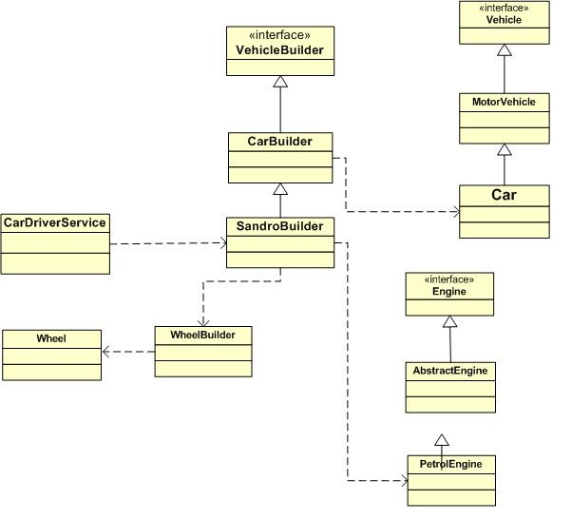

Class | Description
Engine.java | Illustration of the Interface. It is the specification for engine.
AbstractEngine.java | Illustration of the abstract class. It is the abstract implementation of Engine.
PetrolEngine.java | Illustration of the concrete class and inheritance. It is the concrete implementation of Engine.
Vehicle.java | Illustration of the Interface. It is the specification for a vehicle.
MotorVehicle.java | Illustration of the abstract class. It is the abstract implementation of Vehicle.
Car.java | Illustration of the concrete class and inheritance. It is the concrete implementation of Vehicle.
Wheel.java | Encapsulate a Wheel entity.
WheelBuilder.java | Specification for building a Wheel.
VehicleBuilder.java | Illustration of the Interface. It is the sspecification for assembling a vehicle.
CarBuilder.java | Illustration of the abstract class. It is the abstract implementation of VehicleBuilder.
SandroBuilder.java | Illustration of the concrete class and inheritance. It is the concrete implementation of Engine.
CarDriverService.java | It constructs a car by delegating to the appropriate VehicleBuilder class.

What you need to do ?

You need to explore through the files in your workspace project and understand how each collection type is used. You may run the classes and see the console output for details. You may debug the programs to step through the execution steps and see what is happening as well.

There are some places you can see unimplemented code fragments with a // TODO: Implement mee... notation which asks you to implement that part by yourself.

You may add your own test cases and try out more scenarios until you become well versed and confident on the topic.

How to execute the test cases.

To run the project expands the package “com.aitrch.corejava.oop.service” run the class “CarDriverService”. This class has a main method with which you can right click and Run as Java Application.

